
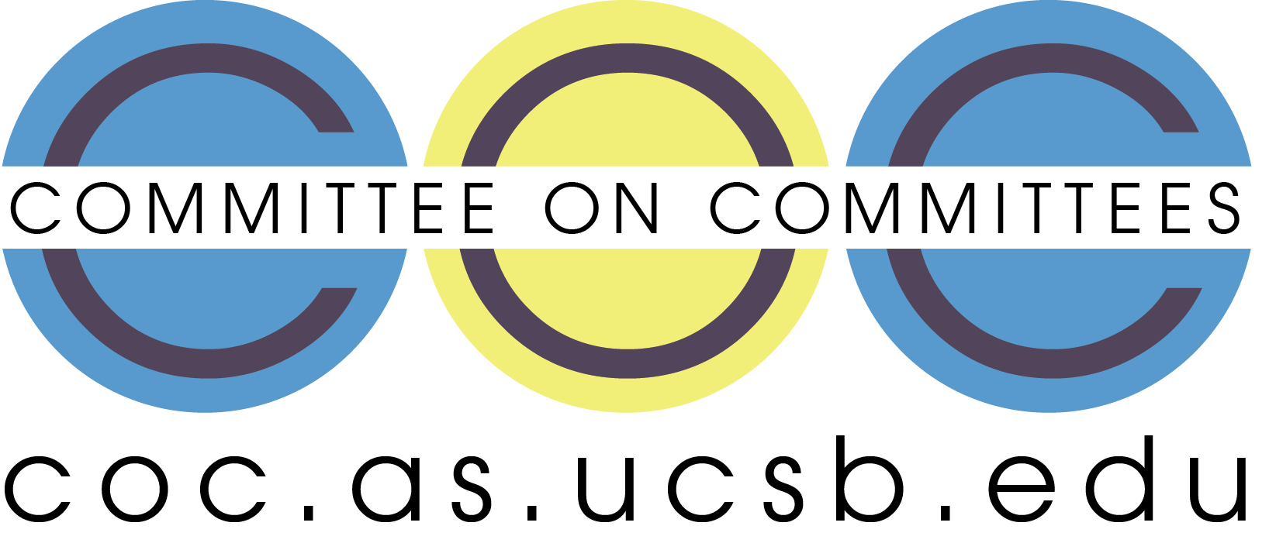

Committee on Committees Minutes

Associated Students
DATE: November 10th, 2025
LOCATION: Pardall Center Minutes/Actions recorded by: Shuyi Sum

CALL TO ORDER: 7:08 by Lily Strange, Internal Chair

QOTW: If you were a holiday candle, what would you smell like?

A. MEETING BUSINESS

- Roll Call

Name | Note:  absent (excused/not excused)  arrived late (time)  departed early (time)  proxy (full name) | Name | Note:  absent (excused/not excused)  arrived late (time)  departed early (time)  proxy (full name)
Sophia Fei | Excused | Yeshua Valdez Rodriguez | Excused
Lily Strange | Present | Savanah Lizet Aldaba | Present
Shuyi Sum | Present | Adam Orenstein | ...
Oliver Ramirez Carrera | Present
Layla Hakim | Present
Mira Ikladious | Present

- Acceptance of Excused Absences

MOTION/SECOND: Lily/Shuyi
Motion Language: I motion to excuse Yeshua Valdez Rodriguez and Sophia Fei from tonight’s meeting on November 10th.
ACTION: Consent

- Acceptance of Proxies

B. PUBLIC FORUM

- EXTERNAL REPORTS

- Advisor’s Report

- Executive Officer’s Report(s)

- Group Project/Member Report(s)
  - Advisor and Senate Liaison Reports

Lily Strange - Internal Chair
    - QOTW: fresh linen because I have always yearned to eat a tide pod
    - THANK YOU to all who tabled with me at parents’ and family weekend, we resulted in many parents haggling their children to get involved YAY
    - Requisition form tutorial → in the CoC 2025-26 folder
    - We need to pass $1053.60 for the UCEN reservations for the chair meetings…
    - BUDGET!!!!!!!
      - Sooooo….. THIS IS OKAY. We knew we would have to request more funding anyway 😝 … turns out our budget is not enough to cover honoraria even :(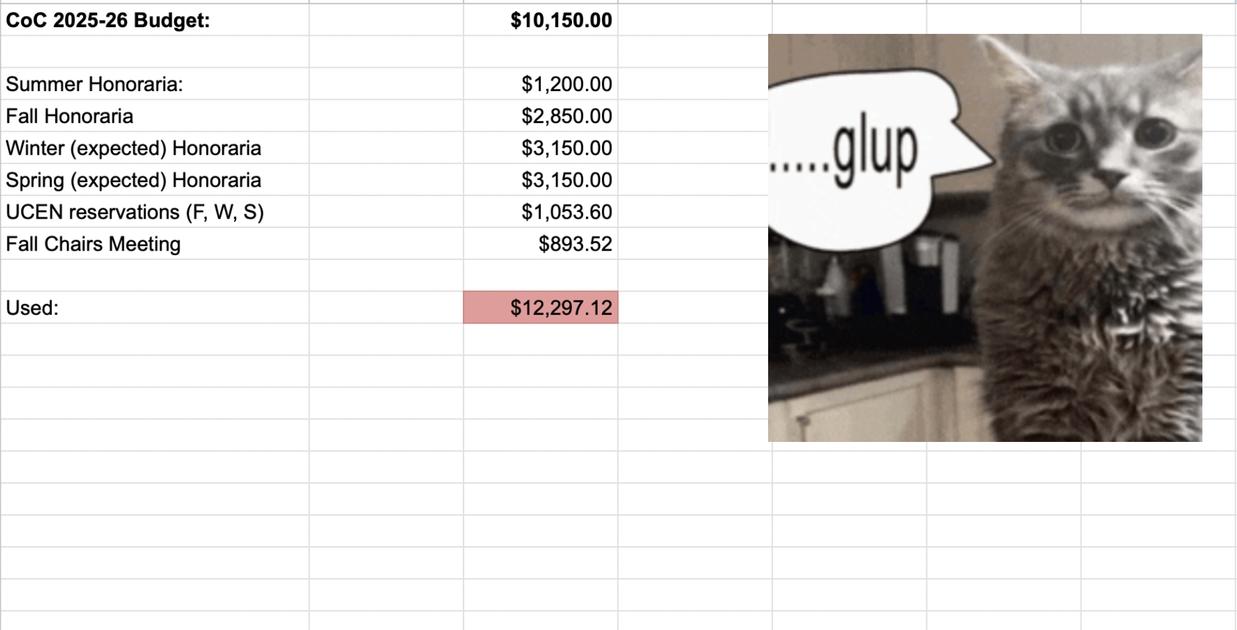

    - Tablecloth…we have a plain white one for now (THANK YOU YESHUA)
      - Should we just hold off until next quarter / when we figure out the budget?
      - Let’s brainstorm some supplies we can use for tabling going forward though! Hopefully we get a budget increase and can order some things in time for winter
        - Tablecloth (we can get an exact price but ~$150?)
          - I’m going to do one last search of the computer room… couldn’t get in last time
          - I did check high and low in the senate room though
        - Stickers!
          - Let’s do cute raccoon AS ones and CoC ones
        - Flyers (and plastic stands like Yeshua let us borrow last weekend)
        - Snacks?
    - Got an application for the OSA position… my b! Closed that on the website and emailed the applicant to apply to the pro temp positions
      - How is pub going for this?... we haven’t had many (any?) applicants ☹️
        - Can we get a IG post ASAP
        - Who have we emailed so far
      - Is anyone available to table with Le Anh at coffee with the Pres (next ones are Nov 18th 2pm-4pm and Dec 2nd 2pm-4pm)
        - To advertise positions in general!
        - Oliver - Nov 18th
        - Shuyi - Dec 2nd
    - 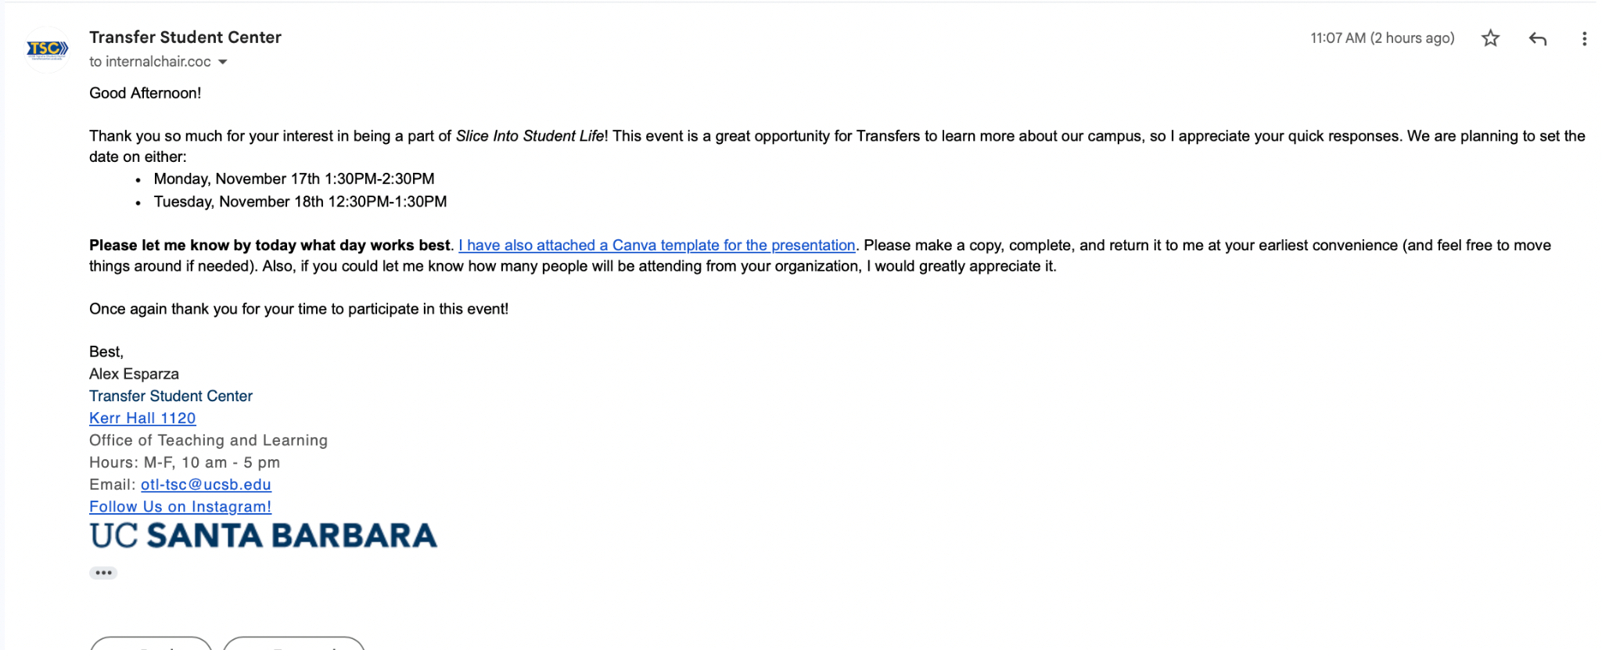
      - Assuming this is next Tues 12:30-1:30pm, who can go?
        - Sophia
        - Layla
        - Oliver
          - This is probably enough!
          - Here are CoC’s slides
    - Reminder for everyone that the AS ONE makeup attendance is due THIS FRIDAY (11/14). Please complete for full honoraria!
    - Our quarterly reports are next week!! I’ll be there, Sophia or Shuyi if you’re available we can all pull up. Anyone else is welcome!
      - Tuesday, November 18th at 6:00-8:30 pm at Corwin Pavilion
      - RSVP here
        - Lowkey I think we submit this as a group so let’s get a count of who is going now:
          - Lily
          - Oliver
      - We need to complete a quarterly report! I can fill it out, but let’s all brainstorm what we can include (numbers and metrics are best)
        - The tabling events we attended / # of tabling events
          - Parent’s / family weekend
          - Pumpkin patch
          - AS Kick off (no tabling but help planning the event)
          - Transfer event
        - Social media interactions
          - Number of posts, stories, how many students reached (likes and views) → Mira do you have intel on this
            - 11.2k views over the last 30 days
        - Interviews done (we can include summer too lowkey haha)
        - Applicants to our positions
          - Sept - Present: 53 applications across 23 applicants and 11 BCUs
          - Not including summer apps !
            - 37 summer applicants and applications, 2 BCUs
        - How many positions we advertised on our website
          - Also emphasize that we host all applications (even external ones) so students can find them in one place → also as PSA to chairs to please fill out our spreadsheet
          - Hired an ENTIRE board from the dead (LHP)
        - Quarterly chairs meeting
      - Budget
      - Organizing the CoC website
    - I am emailing for a website redesign / connecting Yeshua with Alex (the AS website designer)
      - Does anyone have any thoughts on website improvement?
      - This is what I have so far:
        - A main issue we have come across is the website auto-populating an application (the big apply now button when you select a position) when we open a position. Usually, this is great when we host applications on the CoC website. However, many BCU's have their own external applications (google forms, etc) for recruitment. We like to have all open AS positions on our website so students can find them in one place, however the external application link with the auto apply now populated is a bit confusing.
        - Some general ideas we had to make the website more engaging were:
        - - insert the video Sean Lieberman made and showed at the AS Awards Banquet last year (montage of different BCU's photos from the year)
        - - insert an AS Alumni highlight, mainly to show where previous AS officers are now and their perspectives on how AS advanced their career / set them up post grad
        - - a "find your fit" form where students can fill out a form targeting their interests (pre-law, publicity, STEM, etc) that could navigate them to suggested BCUs / AS entities to get involved in
        - - Generally a more streamlined open positions page
          - Filter by just open positions (get rid of no openings clutter)
        - - somewhere to feature photos of past events
    - Social ideas!! I think we discussed dinner week 10 monday
      - Google form vote

Sophia Fei - External Chair

Shuyi Sum - Vice Chair
    - QOTW: Biscoff cookies + earl grey tea (in my grandma era)
    - Emailed Samrita about OSA rejection and Office of Senate positions
    - 1 application for OOS !
    - Can’t make it to quarterly reports or TSC tabling 🙁
    - Table with Le Anh at coffee with the Pres Dec 2nd
    - I can compile a list of all applicants + interviews for report

Oliver Ramirez Carrera - Internal Liaison
    - QOTW: I would want to smell like snow
    - Attending Campus Elections Commission meeting on Wednesday
    - Might be able to start attending EVPLA meetings, going to talk to friend about it
    - Got in contact with Suyan, updated spreadsheet accordingly: up to date so far
    - Can table next week on Tuesday for the Transfer Students event
    - Can also table on the 18th at the arbor

VACANT - Internal Liaison

Layla Hakim - Outreach and Recruitment Coordinators
    - QOTW: Pine trees!!
    - Tabled at the chancellor’s fair, feel like it went pretty well!
      - Plus a little feature on our insta story🤩
    - Emailed advisors about the open senate positions with my proposed email draft, waiting to hear back
    - Planning to table for the TSC event…waiting to get my work schedule though
      - If I can go I will update the fliers I made and print more out to have at our table

Mira Ikladious - Outreach and Recruitment Coordinators
- QOTW!!! Vanilla
- Updated open positions in AS main office
- Posted insta

Yeshua Valdez Rodriguez - Outreach and Recruitment Coordinators

Savanah Lizet Aldaba - Outreach and Recruitment Coordinators
    - QOTW: Marshmallow
    - Attended AS Quarterly- talked about decision making strategies
    - Sat in for the Lobby Corps- Main focus currently is Save Deltopia, no open positions currenly but Local Affairs Chair Lily Meja will reach out to me with future events.

Adam Orenstein - Commissioner of Community and Climate

C. Action Items

- ACCEPTANCE of AGENDA/CHANGES to AGENDA

- CONSENT ITEMS

- Approval of our Action Summary/Minutes from:

- ACTION ITEMS

F-1. Old Business:

F-2 New Business:

- DISCUSSION ITEMS

- Discussion Topic

- REMARKS

- ADJOURNMENT

MOTION/SECOND: Mira/Shuyi
Motion Language: I motion to pass $1053.60 for the UCEN Flying A room reservations during every Monday of week 2 during the Fall 2025, Winter 2026, Spring 2026 quarters for the Chairs Meeting.
ACTION: CONSENT

MOTION/SECOND: Layla/Mira
Motion Language: I motion to adjourn this meeting at 7:30pm on November 10th.
ACTION: CONSENT

